FOUNDATION FOR VIRTUAL AND AUGMENTED REALITY SYSTEMS
Lecture06
Lec 6: Historical Evolution
Hello and welcome to the NPTEL MOOC's course on Foundations for Virtual and Augmented Reality Systems. We are going to start lecture number 4, where in brief we will talk about the historical evolution of the field. So far we have covered a few basic terms and their definitions to get a broader understanding of what this field is, why it is important, and what aspects of the field are important for us to know about. Here, what we will do is we will deviate a little from discussing the concepts;
rather, we will quickly have a look at the historical evolution of the field, which I hope will be of interest to all of you, and, let us quickly have a look at all the things that shaped the present state of the field. We are going to begin with a quick look at the historical evolution of virtual reality; separately we will talk about augmented reality in the later part of the lecture. Now, this evolution of the field we can divide into some distinct phases. Although I have used the term 'distinct,' sometimes there may be a little bit of overlap between the phases.
But mostly we can differentiate key developments which shaped the field in distinct phases mostly. And we can broadly have four phases of evolution of this field, starting with a phase that curiously was there even before the advent of digital computers. So, we can call it the early era, then we have the formative years. which roughly we can associate with the years between 1950 and 1990.
Then we have the modern phase between 1991 to 2015 and the growth phase, which is the current phase where we are all in, which roughly we can say started from 2016 onwards. What we will do is try to get some understanding of these evolutionary phases in terms of the key developments that took place in each of these phases or eras. Now, let us talk about the early era. So, whenever I use the term virtual reality, we immediately associate it with some devices that that are computer in nature.
So, essentially it is difficult for us to think of virtual reality without thinking of computers, particularly computer displays. However, you will be surprised to know that the concept in some form existed even before computers were officially developed in the 1940s, before the advent of modern digital computers in the 1940s. So, of course, not everything was there, but a few things conceptually were similar to what we consider to be immersive experience in virtual reality. There are a few key developments in this era we can roughly associate with virtual reality experience.
The first of those was developed in 1838 by Sir Charles Wheatstone, who demonstrated a stereoscopic device and established for the first time in recorded history that our brain can process 2D images as 3D objects. So, this can be roughly considered to be the first step toward creation of immersive experience. Remember that when we experience virtual reality, we wear either headsets or experience it through some display devices. Each display device is 2D in nature, but due to our stereoscopic vision, we
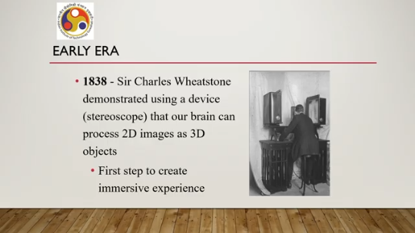
see these images together in the form of 3D objects, 3D space. That is what immersion is all about. And this demonstration way back in 1838 actually established the fact that this is possible. You can see in the accompanying image the kind of device that was developed at that time. Then in 1860, David Brewster created a compact-sized stereoscope, a similar device to create the illusion of depth in viewing images.
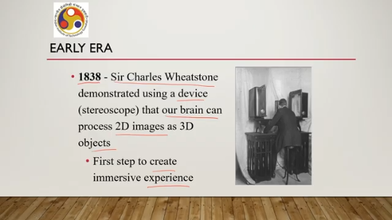
So, when we view images, we can perceive depth through that stereoscopic display developed by David Brewster in 1860 which was, of course, as you can see, an advancement from the earlier invention. This we can roughly consider to be another step toward creating practical immersive experiences. And the accompanying image shows the kind of device that was developed. An early form of stereoscopic displays.
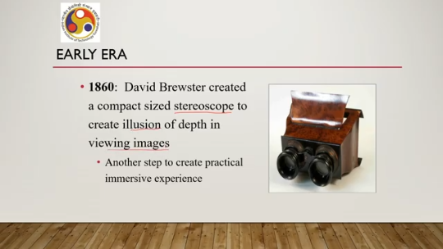
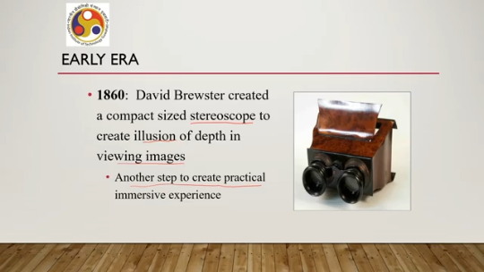
In 1928, the concept of a flight simulator was introduced for the first time by Edwin A. Link. which eventually evolved to present very sophisticated flight simulators. And these flight simulators have multiple sensors to give an immersive experience. And this early development in 1928, shown in this accompanying figure, can be considered to be a precursor to that multi-sensory immersive VR experience, which are prevalent- in modern times.
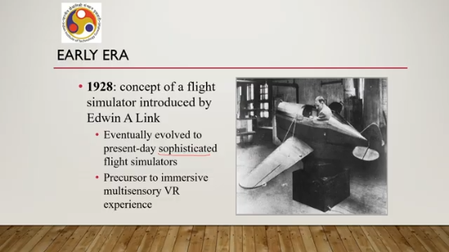
So, that is all about the early era. So, we have these few inventions and developments associated with the early era before the advent of computers. Then, once the computer came into the picture in the 1940s, we entered the second phase of the historical evolution of virtual reality, which we can call the formative years. Roughly, we can associate the interval between 1950 and 1990 to this formative year phase.
Now, in the 1950s, people started working on a new kind of computer display called HMDs or head-mounted displays. Note that at that time, regular computer monitors, CRT screens, were more common as compared to HMDs. But you can notice here that as early as the 1950s, people started thinking of different types of displays or HMDs. This happened particularly toward the latter half of the decade. Then in 1961, engineers at the Philco Corporation developed an HMD which was able to track users' motion much like modern-day HMDs, but as you can see in the accompanying figure,
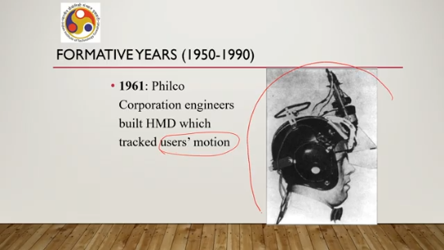
how bulky it looked and how difficult it was to wear such a device as a head-mounted display. Clearly, the usage was not very comfortable. Users were less likely to find comfort after wearing this device. But it was an early development in the evolution of HMDs. In 1962, Morton Heilig introduced Sensorama, another invention.
As shown in this figure here, in the accompanying figure, which at that time was publicized as having many features like 3D, wide vision, motion, color, stereo sound, even smell, wind, vibration. So, in a sense, it tried to engage all our sensory organs. Through the use of smell, wind, vibrations or haptics, along with the sound and stereo sound and other qualities related to display or our visual sense. We can roughly call this to be the first device of virtual reality as it is defined in modern days, in modern times.
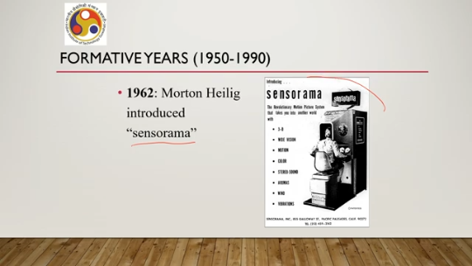
Why? Because using this, a user can feel vibrations, sounds, smell, and wind recorded in advance. Essentially, this device was able to stimulate all our sensory organs to give an immersive experience. So, as per the definition of virtual reality, we can call it the first such immersive virtual reality system. which was developed way back in 1961, in 1962.
Then, in 1965, Tom Furness and colleagues at the Wright-Patterson Air Force Base worked on visually coupled systems for pilots consisting of HMDs. This is another kind of HMD. Named differently, of course, you can see from here. So the HMD looked something like this as shown in the figure. And that was another development in the overall evolution of head-mounted displays. Then in 1967, even Sutherland came up with the particular HMD called Sword of Damocles.
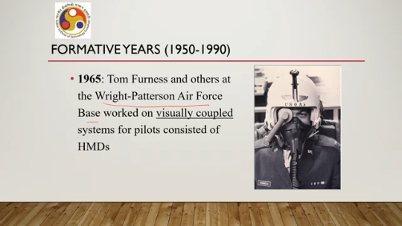
And you can see here how complicated it looked at that time. Of course, it contained lots of components attached to lots of places in the room, but it was a quite revolutionary invention at that time. In fact, he was the first to demonstrate an HMD with head tracking and computer-generated imagery. That was a quite novel invention at that time. Then in 1967 itself, Fred Brooks at the University of North Carolina developed a system with haptic feedback.
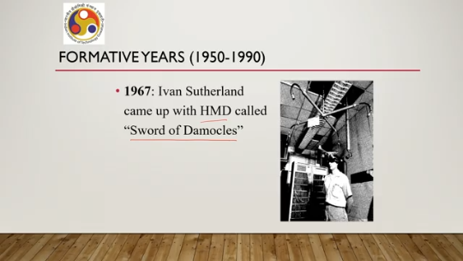
So far, emphasis was primarily given on motion detection or head movement detection. Now, particularly on the input side and output side, of course, Sensorama tried to give some sort of touch sensations, but that was taken further by this invention by Fred Brooks. where haptic feedback was provided as you can see in the accompanying figure. The user can experience through touch sensation whatever is being shown on the screen and while manipulating the objects on the screen, the sensation can be felt through touch. So, these types of haptic feedbacks
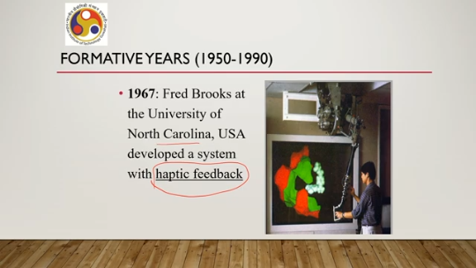
allowed the user to feel objects on the screen. At that time, a force feedback device was used. Nowadays, these types of devices are quite common, but at that time it was one of a kind. So, quite novel at that time. In 1973, Krueger used the term artificial reality.
Now, this was considered to be the early term for virtual reality. So, nowadays nobody uses this term, but at that time this term was proposed which eventually evolved into the modern term of virtual reality. That happened in 1973. Then in 1985, another development took place. Scott Fisher and his colleagues at NASA developed the first commercially viable stereoscopic head-tracked HMD with a wide field of view.
They named it Virtual Visual Environment Display, or VIVED. Note that the earlier HMDs that we talked about are quite costly research prototypes, not commercially available. Only a few were made. Whereas, in 1985, this particular development took place. That is, the first commercially available headset or HMD was developed and launched, which was named VIVED.
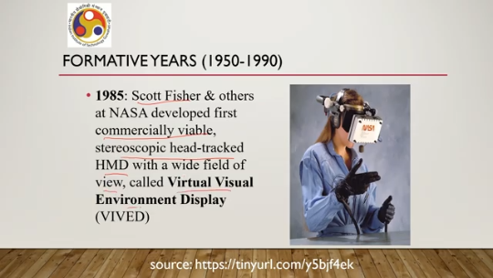
You can see in the accompanying figure how it looked, and since you have already seen the earlier versions of the HMDs, before this 1985 invention, you can now compare their relative complexity. The earlier ones were more complex and difficult to use, whereas this one was relatively less complex. In 1987, two papers appeared in the Scientific American journal. Now, among them, one was on the data glove.
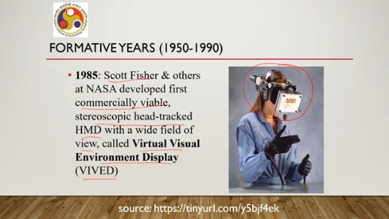
So, at the end of this lecture, I will give you the references to these papers and would like to encourage you to go through the papers, the original papers, to see how things were developing at that time, the perspective at that time. As I said, two papers were there in the Scientific American journal. One of them was on the data glove, which is one kind of input device. We will talk more about that while discussing VR hardware later in this course, while discussing VR hardware later in the course.
Now, these two papers actually played an important role in shaping the field and making the field popular. at that time. Finally, towards the end of this formative years phase, towards the late 1980s, the term virtual reality was proposed by Jaron Lanier, an American, who came up with this term virtual reality at that time. which subsequently, as we all know, is the term used to refer to the immersive technologies.
So, the formative years spanning between 1950 and 1990 led to the popularization of the term virtual reality. In the 1950s, it started with the development of HMDs and towards the end of these formative years phase, the term virtual reality became quite popular. Then we entered the modern phase. This phase spanned between roughly we can associate this phase to the interval 1990 to 2015, about 25 years.
Again, we will be talking about the important developments that took place during this phase. In 1992, the CAVE system was invented at the University of Illinois, Chicago at the Electronic Visualization Laboratory. Now, at that time, that system was having a single Silicon Graphics computer which rendered images in a surrounding setting that felt like one was surrounded by holograms. So, essentially it gave some sort of immersive experience in that cave system.
Now, so far we mostly talked about hardware development. During this modern phase, several things happened on the software front as well. In 1992 itself, when that CAVE system was made, the company Sense8 developed the WTK package for higher level application development in VR. So, that is one software package that was developed, which again helped in building such systems. In 1994, VRML or virtual reality modeling language was presented.
Now, after that, many modeling languages for VR appeared, such as X3D, Java 3D, and so on, but all of these started in 1994. In the modern phase, with the development of VRML, virtual reality modeling language. In 2006, Mark Bolas of the University of Southern California's MXR lab and Ian McDowall of Fakespace Labs created a 150-degree FOV field of view HMD called White 5. So, this is another development in the progression of revolution of HMDs.
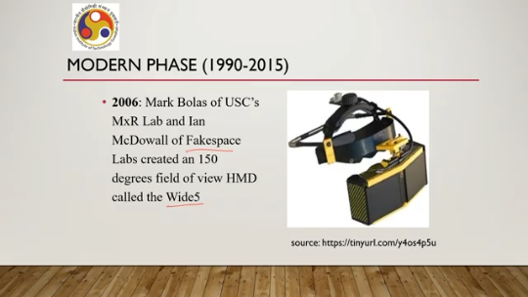
Now, the HMD that was developed at that time in 2006, you can see here in the accompanying figure. If you keep the earlier HMDs side by side, starting with the late 1950s, whatever was developed at that time, then subsequently Sutherland's HMD, and then the NASA HMD, and so on, you can see how things are changing, how things have changed at that time. From quite bulky appearance, it became quite portable and less bulky and more usable in a sense.
In 2012, very recently, Palmer Luckey, who was 19 years old at that time, very young, created an inexpensive VR headset, which was called Oculus Rift. Now, this actually spurred interest in VR like anything. Later on, Facebook purchased it in 2014. And with that purchase, they tried to popularize it.
and made things affordable for the masses, and in a sense, this Oculus Rift headset, which you can still see around, still available, although no longer, supported much, became quite popular at that time, and people started having interest in this field because of these inexpensive headsets. The availability of inexpensive headsets and that development we can say towards the end of the modern phase spurred the interest in this field to a great extent. Finally, we are going to discuss the last and continuing phase, that is the growth phase, which roughly we can say started from 2016 onwards. Now, why this 2016?
Because in that year, many well-known companies released commercial VR headsets, which made immersive experiences affordable to a large population, which in turn spurred growth of the field. So, Facebook came up with Oculus Rift version 1. Then HTC came up with HTC Vive. Sony came up with PlayStation VR. Microsoft came up with HoloLens.
So, all these are quite famous and popular. Some of them are still around and in, of course, latest versions. Then in 2021, Zuckerberg of Meta popularized the term Metaverse. This metaverse term was actually there since the 1990s; however, at that time, it was within the research community, and nobody paid much attention to it, but with the use of this term by Zuckerberg, people started taking interest in the meaning of this term, and different people started interpreting it in different ways, spurring
interest and further activity in the field only a couple of years back. In 2023, Apple came up with its own VR headset, Apple Vision Pro. So as these developments show, these types of things are continuing. So we can say that the story continues. More and more such developments will happen in terms of better headsets, better immersive displays, better input devices, and so on.
So from here, Things can only grow. That is why we are calling this continuing phase the growth phase. So, the story continues. It will keep on happening.
And as we discussed in the first lecture, since there is going to be huge demand, all these developments will continue and may even accelerate. So, that is, in very brief, what the key developments that shaped this field are. So, with that, we have come to the end of this part of the lecture. Here we discussed historical milestones in VR. So, we talked about four developmental phases or evolutionary phases.
One phase started even before the advent of the digital computer. A few developments there actually relate to the immersive experience. So, we kept it as part of this historical development. Then there are the other three phases. formative years, modern phase, and growth phase.
And we have also noted key milestones in each of these phases. In the next lecture, we will be talking about the next part of the lecture, where we will discuss the history of AR in a similar manner, that is, in terms of phases and key milestones. Knowing history is always interesting, of course, and I hope that this brief history of the evolution is of interest to all of you, like this discussion. For further details, you can refer to this book and some other references that were mentioned, which will come at the end of this lecture, that is, after we talk about the history, but this book is
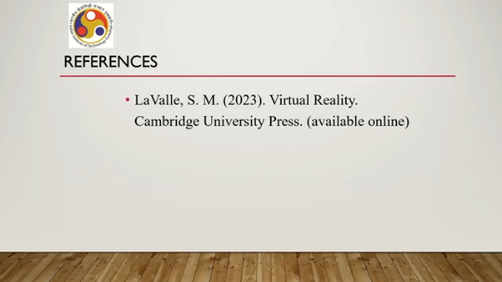
available online. You can have a look at this book by LaValle, where this historical evolution is covered in detail. So, with that, I would like to conclude this part of the lecture. Thank you. Hope you enjoyed.
Happy learning. See you in the next part.

